School Strategic Plan for
Woori Yallock Primary School
1259
20 16-19

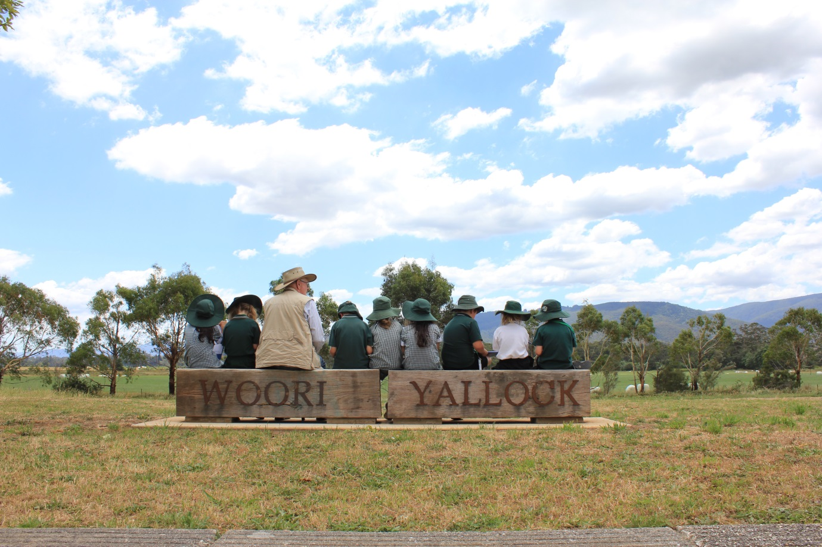

Endorsements
Endorsement by School Principal | Signed……………………………………….  Name………………………………………….  Date……………………………………………
Endorsement by School Council | Signed……………………………………….  Name………………………………………….  Date……………………………………………  School Council President’s endorsement represents endorsement of School Strategic Plan by School Council
Endorsement by the delegate of the Secretary | Signed……………………………………….  Name………………………………………….  Date……………………………………………

School Profile
Purpose | Through a comprehensive curriculum, personalised learning, exceptional teaching and high expectations we ensure that when students graduate, all opportunities in life will be open to them. This will be provided in a safe and supportive environment that promotes life-long learning.
Values | High expectations - Ensure that our whole school community’s words and actions reflect high standards of personal and academic achievement and that student goals are extending all of their capabilities.  Respect - Caring for and having high regard for yourself, all others and your environment. Listening to beliefs and opinions without judgement and accepting diversity.
Environmental Context | Woori Yallock Primary School is located in the township of Woori Yallock in the semi-rural Upper Yarra Valley  some 60 kilometres from Melbourne GPO. The school was established in 1874 and moved to the current site in 1984. The school is within the Yarra Valley Network of schools and close ties are established with the local  Woori Yallock Pre-school. Our grade 6 students upon graduation go to a range of different secondary settings.  The school has a number of government schools in close proximity. Enrolments come from predominantly the local kindergarten, but also get small enrolments from other early learning centres from the wider district. After a long decline in enrolments over the last 2 decades (325 in 1992), numbers have started to increase again over the current strategic plan (171 in 2012 to 192 in 2015) and projections place the school at 220-250 students over the next few years. The district has an ageing demographic.  One of the challenges the school faces is some transience in the school community with new students coming to the school, and about the same number leaving, at all grade levels through the year.  The school’s SFO is relatively high 0.65-0.67, placing the school in the top third of disadvantage which qualifies for a primary well being officer.  In 2015 there are three students with a Koorie background but no students with a language background other than English (LBOTE) enrolled at the school. The school has a Program for Students with a Disability (PSD); there are eight funded students attending Woori Yallock P.S. in 2015 allowing for teacher aides support in classrooms. Each year there are a number of Out of Home Care students enrolled at the school.  The school grounds are well maintained and reflect the considerable community engagement in the school and the focus on sustainability evident in the well-established native vegetation, frog bog, vegetable patch and tanks harvesting water from the school roof system. Becoming a Stephanie Alexander Kitchen Garden Program school in 2012 further built on this. There is a pet enclosure in a secure courtyard. Hard surface areas and extensive grassed areas provide ample playing spaces.  Classrooms have been transformed from traditional spaces into flexible learning spaces that are more suitable for 21st century learning. The school has a 1:1 iPad program at grade 3/4, a bank of netbooks used by grade 5/6, 22 chrome-books available for use across the school and banks of desktop computers in classrooms. There is an art-room and kitchen. The kitchen was built and funded by the federal government initiative, Building the Education Revolution (BER).  There are eight classes and each is a multi-age grouping except for a Prep class.  .  The school has a stable leadership team including the principal, assistant principal, four teachers and the primary wellbeing officer.  Specialist programs are provided in art, physical education and German (LOTE).  The school has had a greater focus on the performing arts in recent years, holding annual school productions, being involved in State Schools Spectacular in 2013 and 2014, and running a Youth Theatre Group out of the school in terms 1 & 2 in 2015.  A wide variety of co curricular activities is provided to students by staff and the community including a focus on performing arts  The school has an Out of Hours School Care Program pre and post school.  The school has an extensive electives program, often vertically run across grades.  The school has been on a rapid improvement trajectory in recent years reflected by  - being acknowledged in the top 59 schools in Victoria and top 300 in Australia for learning growth [numeracy]  - presenting at the Australian College for Educational Leaders conference in 2014 – ‘How to raise literacy outcomes through a whole school approach’.  - presenting in 2015 at the Creating a High Performance Learning Culture International Conference
Service Standards | - The school guarantees all students access to a broad, balanced and flexible curriculum including skills for learning and life.  - The school has high expectations for the achievement and wellbeing of our students.  - The school provides a safe and stimulating learning environment to ensure all students can achieve their full potential.  - Our teachers will plan their lessons sequentially and effectively with explicit learning intentions and success criteria that are clearly communicated to students.  - All students will receive instruction that is adapted to their individual needs.  - The school provides opportunities for children to become engaged in rich and varied learning experiences that respect and suit their stage of development and promote the growth of the whole child; emotional, social, language, cognitive, spiritual and physical.  - Staff will be proactive in promoting a positive classroom environment that will include carefully planned activities and clean and organised learning spaces.

Achievement |  | Key improvement strategies
Goals | To improve learning outcomes for all students in literacy and numeracy significantly beyond current expected levels. | - Build the instructional capacity of every teacher by embedding a whole school research-based instructional approach.  - Build teacher capacity in the rigorous use of student performance data and evidence to ensure a consistent whole school approach to teaching and learning.  - Use of coaching and peer observation to improve teacher practice.  - Videoing of practice to: embed teacher reflection, capture exemplary teaching, and ensuring consistency of instruction across the school.
Targets | TEACHER JUDGEMENTS  SUBJECT TARGET (P-6)  Reading A/B 55%  Reading D/E 5%  Writing A/B 45%  Writing D/E 8%  Speaking & Listening A/B 40%  Speaking & Listening D/E 5%  Number A/B 55%  Number D/E 5%  Measurement & Geometry 50%  Measurement & Geometry 5%  NAPLAN  SUBJECT TARGET  Reading (above NMS) 95  Reading (at NMS) 5  Reading (below NMS) 0  Writing (above NMS) 95  Writing (at NMS) 5  Writing (below NMS) 0  Spelling (above NMS) 92  Spelling (at NMS) 8  Spelling (below NMS) 0  Grammar & Punctuation (above NMS) 95  Grammar & Punctuation (at NMS) 5  Grammar & Punctuation (below NMS) 0  Numeracy (above NMS) 98  Numeracy (at NMS) 2  Numeracy (below NMS) 0  EXTENSION TARGETS - NAPLAN:  For the percentage of students achieving in the top 2 bands on NAPLAN (Gr 3 – bands 5 & 6, Gr 5 – bands 7 & 8) to be the following by 2019:  SUBJECT TARGET  Reading 60%  Writing 45%  Spelling 45%  Numeracy 60%  Grammar and Punctuation 60%  VALUE ADDED NAPLAN  For growth in all of the dimensions measured to be above the state average.  SFO  For all school mean percentiles to be above our SFO percentile range in every area of literacy and numeracy
 | Actions | Success criteria
Year 1 | - Align current school curriculum with the Victorian Curriculum.  - Professional learning for staff around the ‘critical and creative’ capability in the Victorian Curriculum  - Continue to scope and sequence key domains of the curriculum outside of literacy, numeracy, history and science.  - Build in the teaching of fundamental motor skills into the school’s curriculum.  - Align electives, specialist programs and the Victorian Curriculum.  - Coaching to continue in relation to literacy and numeracy.  - In literacy a focus on vocabulary and inquiry for staff professional learning.  - Implement Google Classroom for units of work across the school.  - In numeracy focus on problem solving and continue our study group around Linda Gojack’s text.  - Implement the Japanese professional development process of lesson study.  - Continue videoing of practice to: embed teacher reflection, capture exemplary teaching, and ensuring consistency of instruction across the school.  - Revisit the school’s assessment schedule to ensure that assessments provide the most valuable information for all students and in particular higher achieving students.  - Refine the whole school data spreadsheet to ensure efficiency and relevance.  - Celebration of data to continue at every opportunity.  - Learning intentions and success criteria are visible in all lessons across the school, not just in literacy and numeracy.  - Articulate a narrative for what a Woori Yallock PS graduate would be able to exhibit to parents and the community. This narrative would build on the literacy and numeracy capability improvements already realised and emphasise the importance of physical and aesthetic development and continued focus on citizenship as part of students’ personal and social development.  - Purchase a whole school licence for Fast For Word.  - Directly employ a speech pathologist to target incoming Foundation students, students attending playgroup and other students at risk. | - Victorian Curriculum reflected in planning documents.  - Teachers integrating the ‘critical and creative’ capability into planning.  - Scope and sequence(s) developed and documented.  - All students assessed against the fundamental motor skills.  - Curriculum alignment documented.  - Coaching timetabled.  - Explicit teaching of vocabulary in work planners. Evidence of the different types of inquiry present in planning documents.  - Google classroom in use across the school.  - Improved student outcomes in problem solving. Videos of exemplary problem solving lessons captured.  - Final lesson of the Japanese professional development process videoed. Each level goes through the process three times for the year and the final lesson is delivered by a different teacher each time.  - Videos of exemplary teaching captured.  - Students who have ‘topped out’ on the Fountas & Pinnell benchmark assessment are given assessments which can measure their learning growth.  - A one page spreadsheet for each grade level captures all of the data required for goal setting and growth.  - Celebration build into the meeting schedule.  - Learning intentions and success criteria evident in all planners and are visible in each classroom in each lesson.  - Narrative documented and shared with the school community.  - Licence purchased.  - Consultant employed.
Year 2 | - Review scope and sequences developed.  - Continue to scope and sequence any domains not yet completed.  - Explore the possibility of directly employing an Occupational Therapist for students who have difficulty with fundamental motor skills.  - Begin a new study group. Topic to be determined from needs analysis.  - Place exemplary videos on web-based intranet.  - Analyse data from the Fast For Word program to ascertain effectiveness.  - Review the alignment of electives, specialist programs and the Victorian Curriculum. | - Scope and sequences reviewed.  - Scope and sequences of other domains completed.  - Students having access to an Occupational Therapist.  - New study group commences.  - Videos placed on intranet.  - Effectiveness of Fast For Word measured.  - Alignment of curriculum reviewed.
Year 3 | - Continue with previous year’s study group or begin another one based on needs analysis.  - Review scope and sequences.  - Video exemplary lessons in curriculum areas that haven’t been captured yet. | - Study group continues or new one commences.  - Scope and sequences reviewed.  - Videos in other curriculum areas captured.
Year 4 | - Continue with previous year’s study group or begin another one based on needs analysis.  - Review scope and sequences.  - Video exemplary lessons in curriculum areas that haven’t been captured yet. | - Study group continues or new one commences.  - Scope and sequences reviewed.  - Videos in other curriculum areas captured.

Engagement |  | Key improvement strategies
Goals | To foster a vibrant and supportive school community that engages students in their learning and promotes student wellbeing. | - To provide a stimulating learning environment that fully engages all students in their learning and fosters positive wellbeing and connectedness.  - Effective integration of ICT into all aspects of teaching and learning.  - To develop greater student voice in the school and in their learning.  - To have PSG meetings each term for: PSD students, Aboriginal and Torres Strait Islander students, and Out of Home Care students. These students to also have an ILP.
Targets | Attendance  The average days absent per student to be reduced to 10 days or less by 2019.  ATTITUDES TO SCHOOL  By 2019 the following combined years 5 and 6 means to improve:  Average  Teacher Effectiveness 4.6  Teacher Empathy 4.6  Stimulating Learning 4.4  School Connectedness 4.6  Student Motivation 4.7  Learning Confidence 4.3
 | Actions | Success criteria
Year 1 | - Revisit the behaviour management approaches using as a starting point a teacher feedback audit on the consistency with which classrooms have embedded innovations which have been introduced during the last 2-3 years. Elicit views on those innovations perceived to be most effective and concentrate collaboration on those which are agreed.  - Continue to embed student voice in classroom learning through student goal setting and self-assessment alongside building opportunities for school-wide leadership and contributions to school life.  - eLearning plan to be reviewed.  - Review the ILP template that is currently used.  - Investigate making the school’s intranet web-based.  - Investigate student voice in curriculum planning.  - Continue to make student data clear and visible for students and families.  - Continue to make explicit for parents the nature of student learning programs and ways to enhance learning at home. | - Audit conducted and the most effective strategies maintained and innovations with less impact have been abandoned.  - All students can articulate their individual goals.  - eLearning plan reviewed.  - ILP template modified for ease of use (still captures required information).  - Intranet is web-based and utilised regularly by staff.  - Discussions held with students regarding curriculum.  - Communication of student growth occurs at key times through the year.  - Videos made for parents to support their child’s learning.
Year 2 | - ePotential tools to be used to improve staff ICT skills.  - Visit schools that are seen as leaders in ICT. | - An increase in the ICT skills staff possess.  - Schools visited.
Year 3 | - Fully embed the eLearning plan. | - Classroom observations and video reflect that the plan is embedded.
Year 4 | - Investigate new technologies for their use in classrooms to complement teaching and learning practices at WYPS. | - New technologies sourced and mapped against current and future curriculum.

Wellbeing |  | Key improvement strategies
Goals | To enhance student wellbeing and resilience built on respectful relationships, agreed values and high expectations. | - To promote and develop the strong sense of community evident in the school.  - Encouraging safe and responsible living in a connected world.  - Teach students the knowledge and skills they need to be caring and socially responsible.  - Provide students with opportunities to be active participants in making a difference in the wider world.
Targets | ATTITUDES TO SCHOOL  By 2019 the following combined years 5 and 6 means to improve:  Student Morale 6.0  Classroom Behaviour 3.8  Student Safety 4.6  Student Distress 6.2  Connectedness to peers 4.6
 | Actions | Success criteria
Year 1 | - The ‘personal and social capability’ in the Victorian Curriculum can be a useful entry point to strengthen the work already well underway in building this capability in students. Assessing the current work in positive psychology, the Steps-Board and Citizenship against this scoped and sequenced capability could help affirm the most effective strategies under way, and perhaps abandon some innovations which are only partially adopted.  - Widen the potential use Compass as part of exploration and support for family/parent involvement in home learning to support class learning.  - The school’s vision to create a community hub, building on its pre and after school care/playgroup and other community engagement should be pursued in the next Strategic Plan. Using current resources and linkages can provide a platform for a wider opportunity down the track.  - Develop a survey to evaluate the success or areas for improvement regarding transition processes.  - Documenting the effective transition program provided to all students entering the school at non-traditional grades and times. | - Most effective strategies maintained and abandonment of innovations that have less impact.  - Increased access to services at school.  - Survey developed and administered.  - Transition process documented.
Year 2 | - Review transition survey.  - Map the services available to the school against a wellbeing needs analysis. | - Transition survey reviewed and improvements implemented.  - Services mapped against analysis and any gaps identified. New services investigated to address any gaps.
Year 3 | - Investigate any new services available and how that will benefit the WYPS community. | - New services promoted within the community and accessed by members of the community.
Year 4 | - Investigate any new services available and how they will benefit the WYPS community. | - New services promoted within the community and accessed by members of the community.

Productivity |  | Key improvement strategies
Goals | To strengthen professional capacity of all staff to support student learning, engagement and wellbeing through effective use of time, space, funding, facilities and community resources. | - Facilitating coaching and improved feedback.  - Supporting the better use of ICT to support teaching and learning.  - Auditing innovations and identifying those with the most impact.  - Utilising internal and external expertise to deliver professional learning that leads to improved student learning outcomes.
Targets

 | Actions | Success criteria
Year 1 | - Undertake a simple professional audit to be undertaken on the ‘innovations’ introduced in recent years in order to ascertain the degree of implementation and an assessment of those most valued by teachers. This process can help strengthen the evaluation the school has undertaken.  - Continue the school’s PL approach which is widely owned and valued by staff and is contributing to the improvement exhibited across a range of data sets over the life of the previous Strategic Plan.  - The school wishes to plan its next developments in ICT. A detailed analysis of the current situation, best practice and a plan for implementation should be undertaken before further investment. The school’s interest in video for portfolios and student voice could be a focus in this work. This could be done in 2016, ready for implementation from 2017.  - Staff budget and cash budget to be in surplus. | - Audit undertaken.  - Study groups continue to run as part of professional learning for staff.  - ICT analysis completed.  - Surplus budgets.
Year 2 | - Staff budget and cash budget to be in surplus.  - Provide opportunities for staff to lead professional learning internally.  - Implement ICT plan. | - Surplus budgets.  - Professional learning presented by staff who haven’t presented previously.
Year 3 | - Staff budget and cash budget to be in surplus.  - Review ICT plan. | - Surplus budgets.  - ICT plan reviewed.
Year 4 | - Staff budget and cash budget to be in surplus. | - Surplus budgets.

