Purpose
To ensure school staff understand their supervision and yard duty responsibilities.

Scope
The principal is responsible for ensuring that there is a well-organised and responsive system of supervision in place during school hours, before and after school, and on school excursions and camps.
This policy applies to all teaching and non-teaching staff at Woori Yallock PS, including education support staff, casual relief teachers and visiting teachers.
School staff are responsible for following reasonable and lawful instructions from the principal, including instructions to provide supervision to students at specific dates, time and places.

Policy
Appropriate supervision is an important strategy to monitor student behaviour and enables staff to identify and respond to possible risks at school as they arise. It also plays a vital role in helping schools to discharge their duty of care to students.
The Principal is responsible for ensuring that there is a well organised and responsive system of supervision and yard duty in place during school hours, before and after school, and on school excursions and camps and other school activities.
School staff are responsible for following reasonable and lawful instructions from the Principal, including instructions to provide supervision to students at specific dates, times and places. Supervision should be undertaken in a way that identifies and mitigates risks to child safety.

Before and after school
Woori Yallock’s grounds are supervised by school staff from 8.45 until 3.30pm. Outside of these hours, school staff will not be available to supervise students.
Before and school, school staff will be available to supervise the top crossing and the top playground.
Parents and carers should not allow their children to attend Woori Yallock outside of these hours. Families are encouraged to contact Mount Evelyn Primary School OSHC on 0397 362 123 or osh@woori@mtevelynps.vic.gov.au
If a student arrives at school before supervision commences at the beginning of the day, the principal or nominee staff member will, as soon as practicable, follow up with the parent/carer to:
- advise of the supervision arrangements before school
- request that the parent/ carer make alternate arrangements.
If a student is not collected before supervision finishes at the end of the day, the principal or nominee staff member will consider whether it is appropriate to:
- attempt to contact the parents/carers
- attempt to contact the emergency contacts
- place the student in an out of school hours care program (if available)
- contact Victoria Police and/or the Department of Health and Human Services (Child Protection) to arrange for the supervision, care and protection of the student.
School staff who are rostered on for before or after school supervision must follow the processes outlined below.

Yard duty
All staff at Woori Yallock are expected to assist with yard duty supervision and will be included in the weekly roster.
The principal or assistant principal is responsible for preparing and communicating the yard duty roster on a regular basis. At Woori Yallock, school staff will be designated a specific yard duty area to supervise.
The designated yard duty areas for our school are:
Zone | Area
Area A | Outside the prep classrooms/fake grass
Area B | Oval and bottom sandpit
Area C | Bottom Playground and maze
Area D | Playground out the front of the school

AREA D

AREA C

AREA A

AREA B

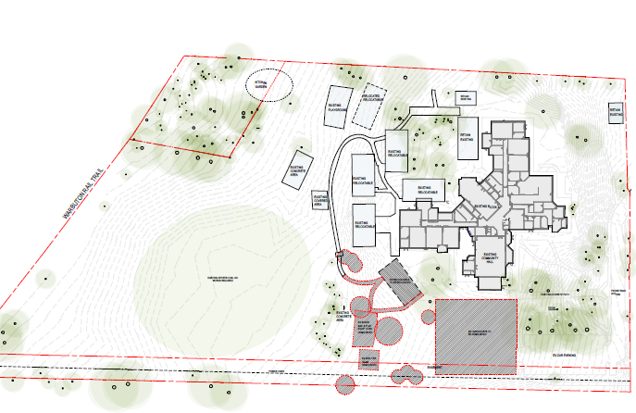

School staff must wear a provided safety/hi-vis vest whilst on yard duty. Safety/hi-vis vests will be stored in the staffroom.
Staff who are rostered for yard duty must remain in the designated area until they are replaced by a relieving teacher.

Yard Duty Responsibilities
During yard duty, supervising staff must:
- methodically move around the designated zone
- be alert and vigilant
- intervene immediately if potentially dangerous or inappropriate behaviour is observed in the yard
- enforce behavioural standards and implement appropriate consequences for breaches of safety rules, in accordance with any relevant disciplinary measures set out in your school’s Student Engagement and Wellbeing policy
- ensure that students who require first aid assistance receive it as soon as practicable
- log any incidents or near misses as appropriate [i.e. in a Yard Duty Book, on Compass – insert school specific procedures]
- if being relieved of their yard duty shift by another staff member (for example, where the shift is ‘split’ into 2 consecutive time periods), ensure that a brief but adequate verbal ‘handover’ is given to the next staff member in relation to any issues which may have arisen during the first shift.
If the supervising staff member is unable to conduct yard duty at the designated time, they should contact the Principal with as much notice as possible prior to the relevant yard duty shift to ensure that alternative arrangements are made.
If the supervising staff member needs to leave yard duty during the allocated time, they should contact the Principal but should not leave the designated area until the relieving staff member has arrived in the designated area.
If a relieving or next staff member does not arrive for yard duty, the staff member currently on duty should call the school and not leave the designated area until a replacement staff member has arrived.
Should students require assistance during recess or lunchtime, they are encouraged to speak to the supervising yard duty staff member.

Classroom
The classroom teacher is responsible for the supervision of all students in their care during class.
If a teacher needs to leave the classroom unattended at any time during a lesson, they should first contact Year Level Coordinator for assistance. The teacher should then wait until another staff member has arrived at the classroom to supervise the class prior to leaving.

School activities, camps and excursions
The principal and leadership team are responsible for ensuring that students are appropriately supervised during all school activities, camps and excursions. Appropriate supervision will be planned for special school activities, camps and excursions on an individual basis, depending on the activities to be undertaken and the level of potential risk involved.

Students requiring additional supervision support
Sometimes students will require additional supervision, such as students with disability or other additional needs. In these cases, the Principal or delegate will ensure arrangements are made to roster additional staff as required. This may include on yard duty, in the classroom or during school activities.

Supervision of student in emergency operating environments
In emergency circumstances our school will follow our Emergency Management Plan, including with respect to supervision.
In the event of any mandatory period of remote or flexible learning our School will follow the operations guidance issued by the Department.
COMMUNICATION

This policy will be communicated to our school community in the following ways

- Included in staff induction processes
- Included in staff handbook/manual
- Included as annual reference in school newsletters
- Made available in hard copy from school administration upon request

YARD DUTY AND SUPERVISION POLICY

PARENTS AND STUDENTS
Student safety at Woori Yallock Primary School is our highest priority and the safe and appropriate supervision of students is an important element of our duty of care to students. Part of this duty is ensuring parents and students are aware of our student supervision arrangements before and after school.
Before school: School grounds are supervised at 8.30 at the kiss and drop as well as the main court yard.
After school: School grounds are supervised until 3.30 at the kiss and drop as well as the top playground of the school.
Students on school grounds outside these times will not be supervised (unless they are attending a before or after school care program or supervised extracurricular activity).
Parents/carers are requested to ensure that students do not attend school outside of these supervised times unless they are attending before or after school care, or a pre-arranged supervised activity (i.e. sports practice).
Families are encouraged to contact Melissa McDonald (Mount Evelyn Primary School OSHC) on 9736 2123 for more information about the before and after school care facilities available to our school community or if you would like any further information about our student supervision arrangements.
For a copy of our school’s Yard Duty and Supervision Policy is available on the school website. This policy includes Woori Yallock Primary School’s student supervision arrangements across the school day, including before and after school.

